SPSS Assignment

# Question 1

**Isabelle's Diner seeks to determine the most effective strategy for attracting customers in the future: (i) offering free appetizers, (ii) providing free desserts, or (iii) having the flexibility to offer either, as there may not be a significant difference between the two**.

***Solution***

The paired-samples t-test analysis was conducted on the mean number of customers during the "Free Dessert" promotion (229.20) and "Free Appetizer" promotion (200.00), and it was found that the mean number of customers in the former is greater than the number of customers in the later. Nevertheless, there is no solid evidence that the two promotional strategies differ significantly ($t(4) = -0.657, p = 0.547$); the results are not statistically significant. The two conditions were moderately correlated ($r = 0.468, p = 0.427$) and some correlation but no statistical significance between customer counts in both promotions. With this in mind, Isabelle's Diner can choose to have the flexibility to provide either promotion on a case by case basis, as the absence of a huge difference between the two tactic is evident from the current data. (See Figure 1 below).

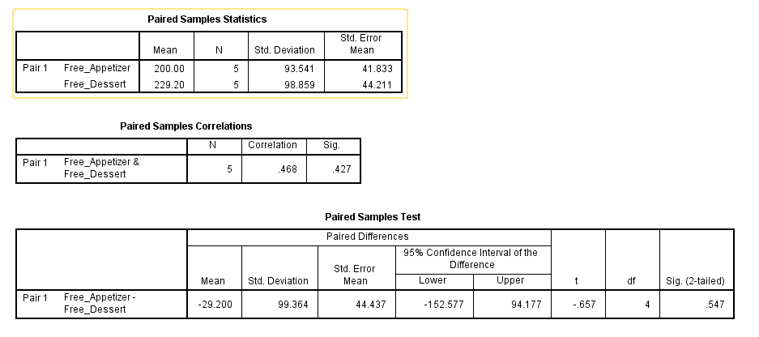

**Figure 1**: *T – Test Analysis*

# Question 2

1. **Do the customers really believe that the organic beef burger tastes significantly better than others, at a 95% confidence interval?**

***Solution***

The results indicate that customers perceive the organic beef burger to taste significantly better than placebo and regular beef burgers. The p-value of 0.000 from the ANOVA test is lower than the threshold set at 0.05 p-value for significance by a 95 % confidence interval. Those ratings show a statistically significant difference between the three groups. The organic beef burger also had the highest mean taste rating out of the placebo (Mean = 2.30) and the regular beef burger (Mean = 2.20); Mean = 6.00. The ANOVA assumptions are confirmed by the variances being equal across groups using Levene’s test for homogeneity of variances (p = 0.717).

1. **Should Daniel continue to keep the organic beef burger on the menu?**

***Solution***

According to the results, Daniel should continue to offer the organic beef burger on the menu. A significantly higher taste rating represents a strong customer preference, which is likely to lead to customer satisfaction and sales.

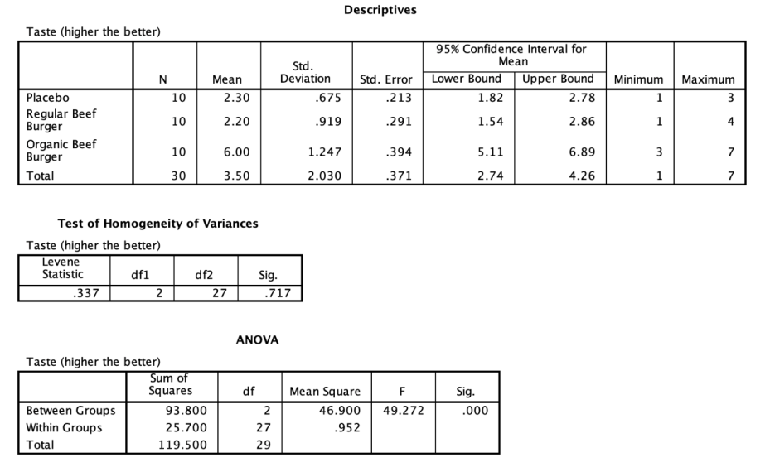

# Question 3

1. **Perform a correlation analysis on the independent variables (price, emails and recentdiscounts).**

***Solution***

Pearson correlation coefficients (in range of r = 0.039 — 0.083 r = 0.083) between the variables PRICE, EMAILS, and RECENTDISCOUNTS are weakly dependent, respectively. None of these correlations are statistically significant because all p values (p > 0.05) do not provide evidence of linear relationships between the variables***.***

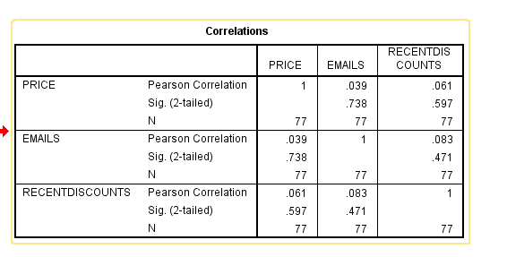

1. **Perform a multiple linear regression analysis. Include an SPSS output screenshot in your answer and interpret the results.**

***Solution***

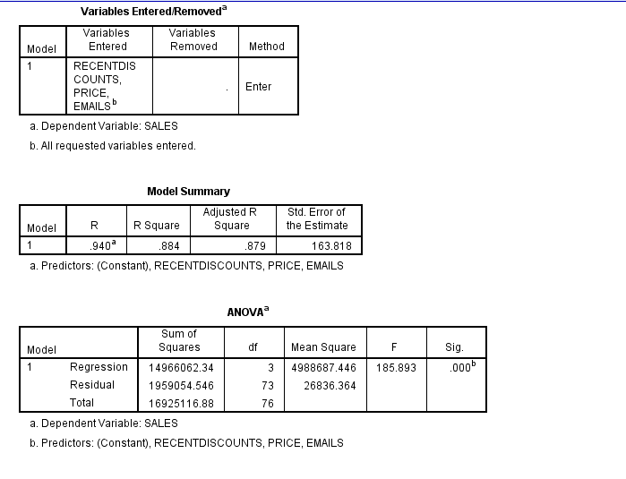

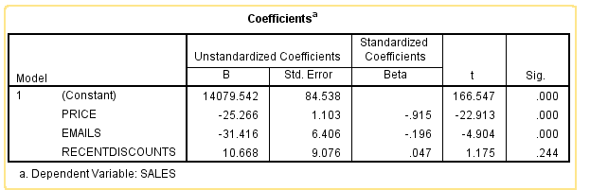

1. **Write your regression equation according to the analysis results.**

***Solution***

*SALES = 14079.54 -25.266(PRICE)-31.416(EMAILS)+10.668 (RECENTDISCOUNTS)*

1. calculate the sales when PRICE = 50, EMAILS = 5, RECENTDISCOUNTS = 6

$SALES = 14079.542-25.266(50)-31.416(5)+10.668(6)$

$SALES=14079.542-1263.3-157.08+64.008$

***SALES* = 12723.17**